130. Surrounded Regions
Medium

Given an m x n matrix board containing 'X' and 'O', capture all regions that are 4-directionally surrounded by 'X'.
A region is captured by flipping all 'O's into 'X's in that surrounded region.

Example 1:
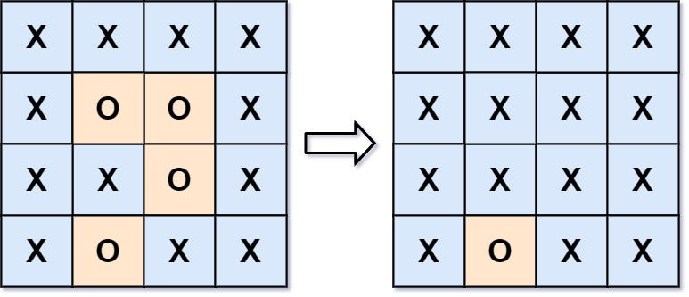
Input: board = [["X","X","X","X"],["X","O","O","X"],["X","X","O","X"],["X","O","X","X"]]
Output: [["X","X","X","X"],["X","X","X","X"],["X","X","X","X"],["X","O","X","X"]]
Explanation: Notice that an 'O' should not be flipped if:
- It is on the border, or
- It is adjacent to an 'O' that should not be flipped.
The bottom 'O' is on the border, so it is not flipped.
The other three 'O' form a surrounded region, so they are flipped.
Example 2:
Input: board = [["X"]]
Output: [["X"]]

Constraints:
- m == board.length
- n == board[i].length
- 1 <= m, n <= 200
- board[i][j] is 'X' or 'O'.

